Visit Derry Call-Out for Bespoke Products 2021
Guidelines for Applicants

Introduction

September 2020 marked the opening of the new state-of-the-art Visitor Information Centre at Waterloo Place. The new centre, located in the heart of the city centre and adjacent to the historic City Walls, acts as a hub for tourists and locals alike. The centre has a gift shop at the heart of its offering and Visit Derry is looking for submissions from local makers to supply bespoke souvenirs. This new state-of-the art facility will rejuvenate Waterloo Place and play a key component in the recovery of the tourism industry post-Covid. In addition to our current offering, we would like to be able to present visitors with the opportunity to buy unique, local products that they cannot get elsewhere.

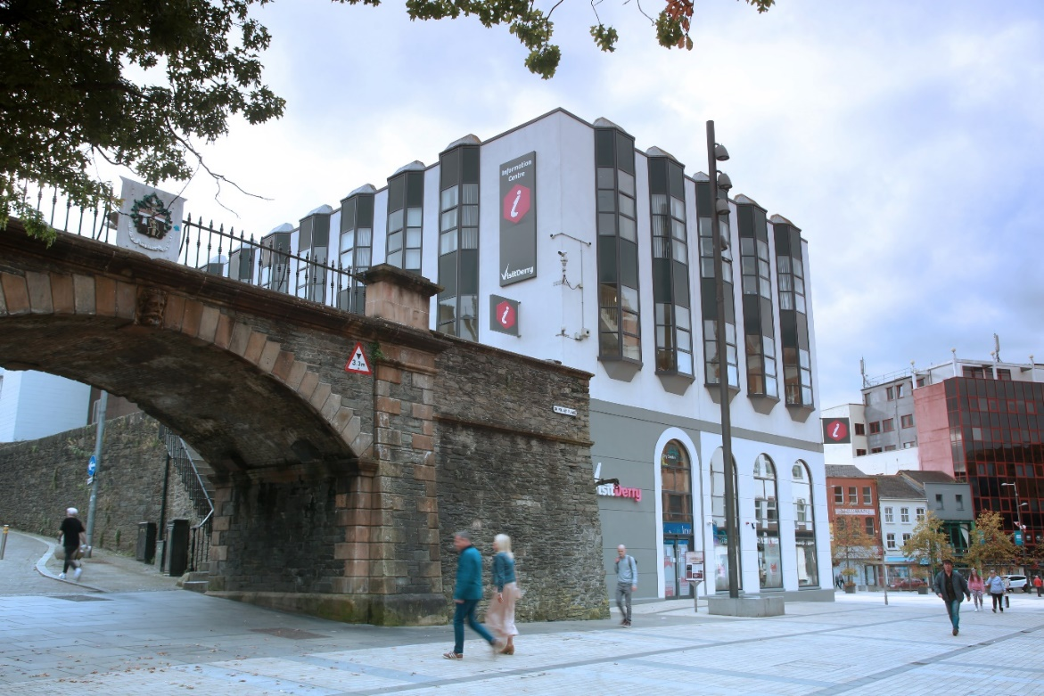

The Process

N.B Artisan Food Applications
Unfortunately, we are unable to accept entries from Artisan Food suppliers at this time. The sale of such items within the centre is managed by the Legenderry Food Group.

Selection Criteria

All of the products must be;

- Hand-made/finished on the island of Ireland
- Applicants own design
- Finished to a high standard
- Durable and fulfil their expected function
- Aesthetically pleasing
- Professionally packaged and presented
- Unique to Visit Derry- the item cannot be sold elsewhere.

It is imperative that applicants comply with the above criteria regarding all of their submissions.

Please note that products should not carry political messages

Assessment of All Applications
A panel will assess each of the applications received, taking the following elements into account;

- Quality and standard of work
- Skill Involved
- Originality
- Price

Useful Information

Visitor Profiles
Post- Covid we have witness a changein our customer profile. Therefore, we need to adapt to shifting customer needs. We foresee demand for quirky, unique items will be popular among our new customers. These may be international visitors, stay-cationers or locals looking to send a piece of home to their loved ones who cannot make their usual visit to the city.

Bestselling Products

From our experience our top selling items would be:
- Low cost
- Lightweight and small in size- for postage/airline restrictions
- Unique
- Quirky- incorporating that great Legenderry sense of humour!

Our best-selling items would fall under the following categories:
- Postcards
- Keyrings
- Magnets
- Pictures/prints
- Local history books

Pricing

Low-cost, pocket-money gifts tend to sell best in this market. We understand that this is not always possible when it comes to craft items but it may be worth considering adapting or modifying your product to take account of this. Visit Derry apply a 30+% mark-up to the cost price provided by all suppliers in the centre. It is worth bearing this is mind as the more competitively priced your item is, then the more it will sell and the more repeat orders will be placed.

Further Information

- Initial orders will be of minimum quantities to gauge demand.
- Visit Derry will be selling the items on its online shop.
- Visit Derry reserves the right to remove stock and cease re-orders if demand is deemed to be insufficient.

Requirements for Submission of Applications

All applicants must submit a completed application. The deadline for applications to be submitted is Wednesday 31st August at 12 noon. Completed applications should be emailed to Catherine.crawley@visitderry.com

